

INTERNAL AUDIT REPORT

Auditee Name:
Department Name :
Job Description:
Audit Date:
Auditor:

AUDIT SUMMARY

ISO 9001:2008 on-site pre-assessment audit conducted for ___________________________by __________________on ________________ for __________________. The scope of the audit is crewing/manning services.

The objective of the audit is to verify if the management system conforms to the requirements of the standard and to confirm the readiness of the organization for a Stage1 audit.

Audit Summary:

Full implementation of the quality management system based on the requirements of ISO 9001:2008 is not evident. The following nonconformities are reported.

1) Nonconformity GGE/01:
- A s H.C.Q.S Manual was established and documented. However, the following deficiencies are noted:
- There is no claim for exclusion. However the organization is not involved in any design & development activities.
- There are no documented procedures for the following:
Control of documents - Clause 4.2.3
Control of records - Clause 4.2.4
Control of non-conforming product- Clause 8.3
Corrective action - Clause 8.5.2
Preventive action - Clause 8.5.3

Requirement:

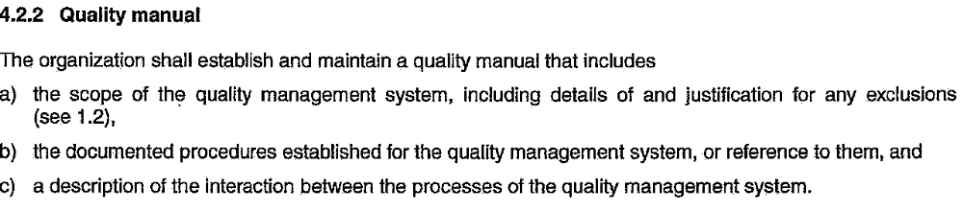

2) Nonconformity GGE/02:
- The quality policy is found not adequate.

Requirement:
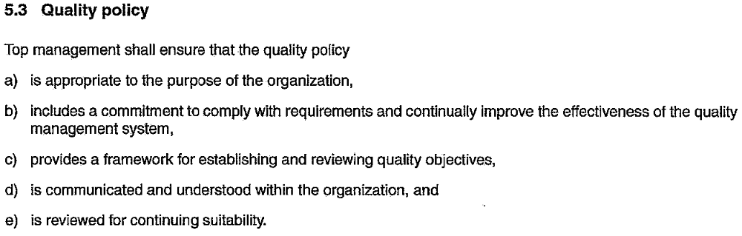

3) Nonconformity GGE/03:
- Management review to ensure adequacy, suitability & effectiveness of the system has not been conducted.

Requirement:
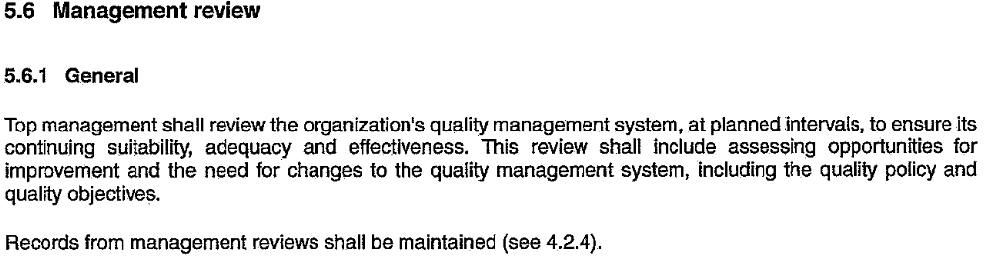

4) Nonconformity GGE/04:
- Internal audit of the quality system to determine conformance to process and product requirements has not been conducted.

Requirement:
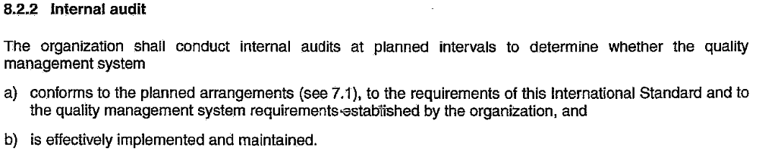

5) Nonconformity GGE/05:
- Measurability of the quality objectives is not established for the following:
- maintain high percentage retention of ex-crew
- maintain high percentage retention of Principals

Requirement:
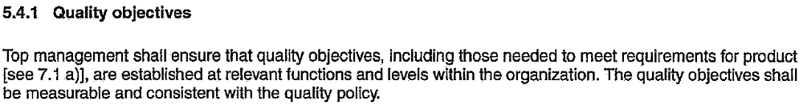

6) Nonconformity GGE/06:
- Employees are not yet fully aware on the requirements/implementation of the Standard.

Requirement:

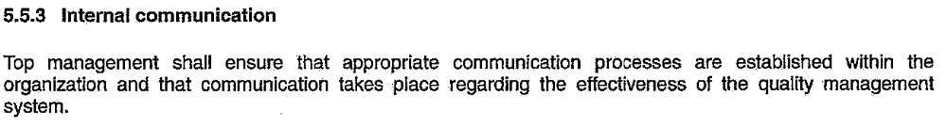

7) Nonconformity GGE/07:
- There is no system of selection, evaluation & re-evaluation of suppliers.
- The type and extent of control over outsourced processes are not defined.

Requirements:


4.1 General requirements

8) Nonconformity GGE/08:
- There is no system for measurement of customer satisfaction.

Requirement:
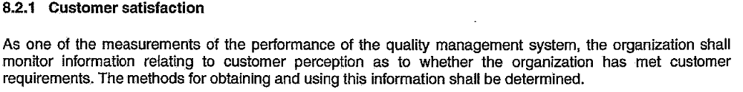

Conclusion:
This audit has confirmed that the organization has not established and maintained its management system in line with the requirements of the standard.

Therefore, it is not recommended to proceed to Stage 1 audit.

